Creating Log Files and Checking Git Status:
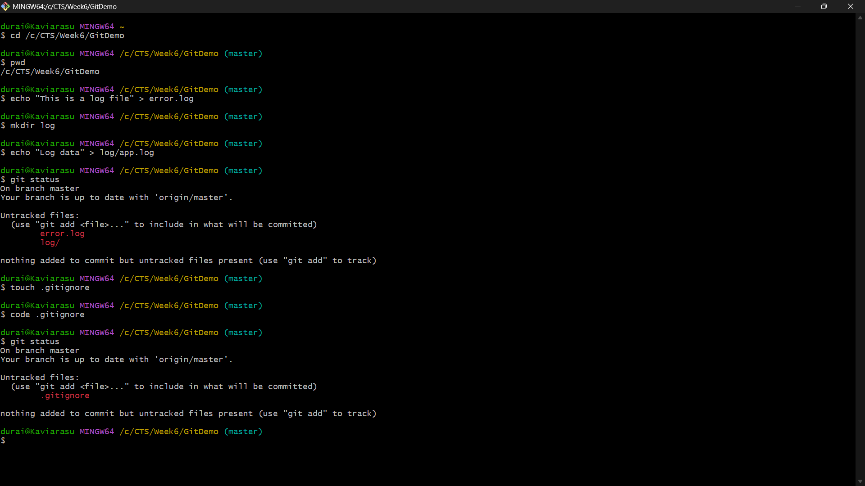
Creating and Configuring the .gitignore File:
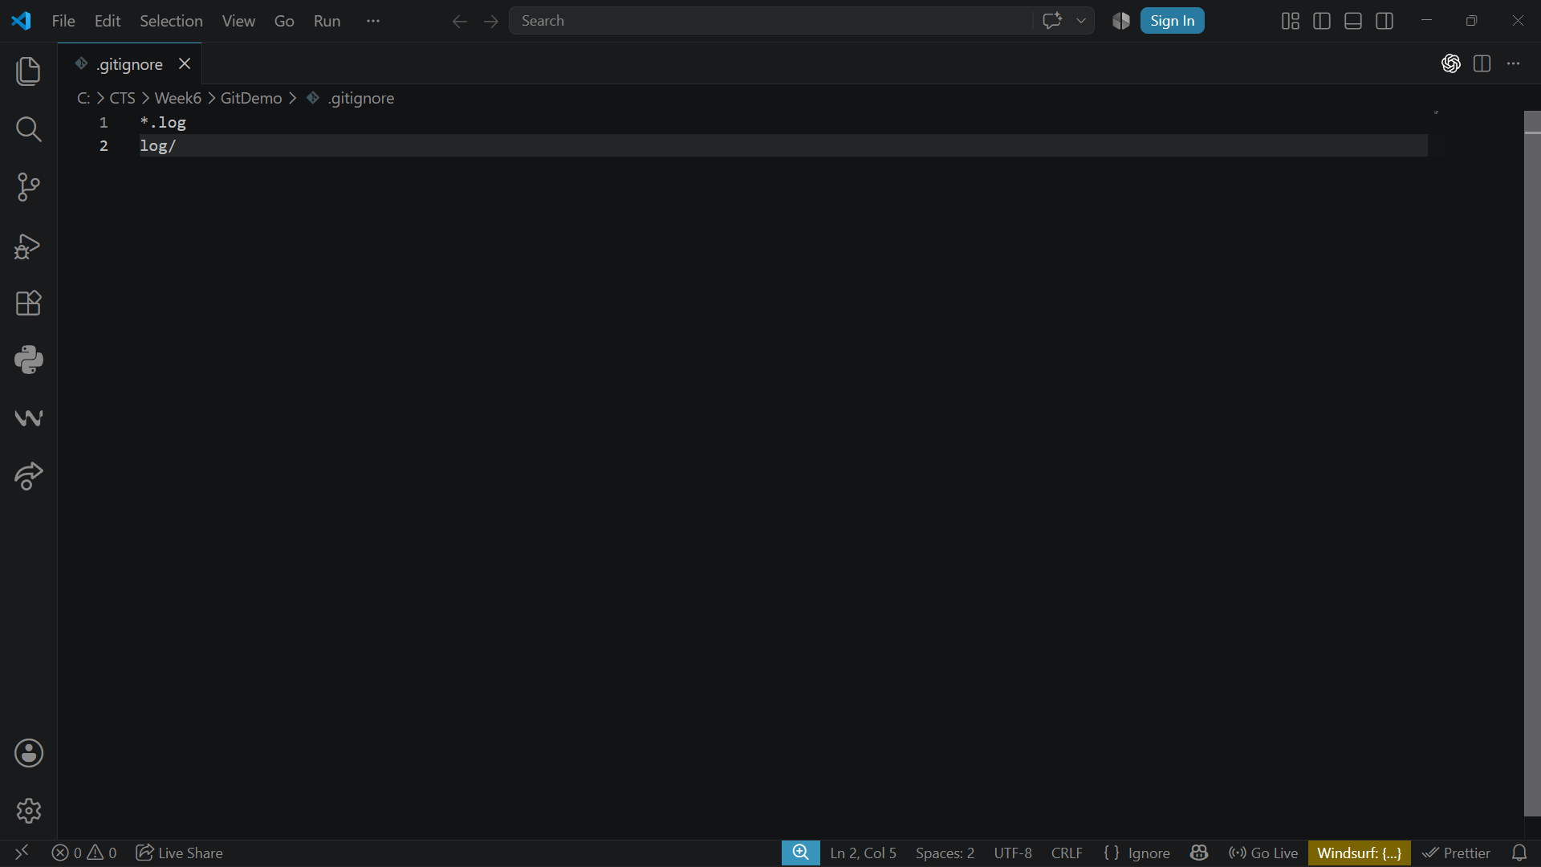

Committing the .gitignore File:
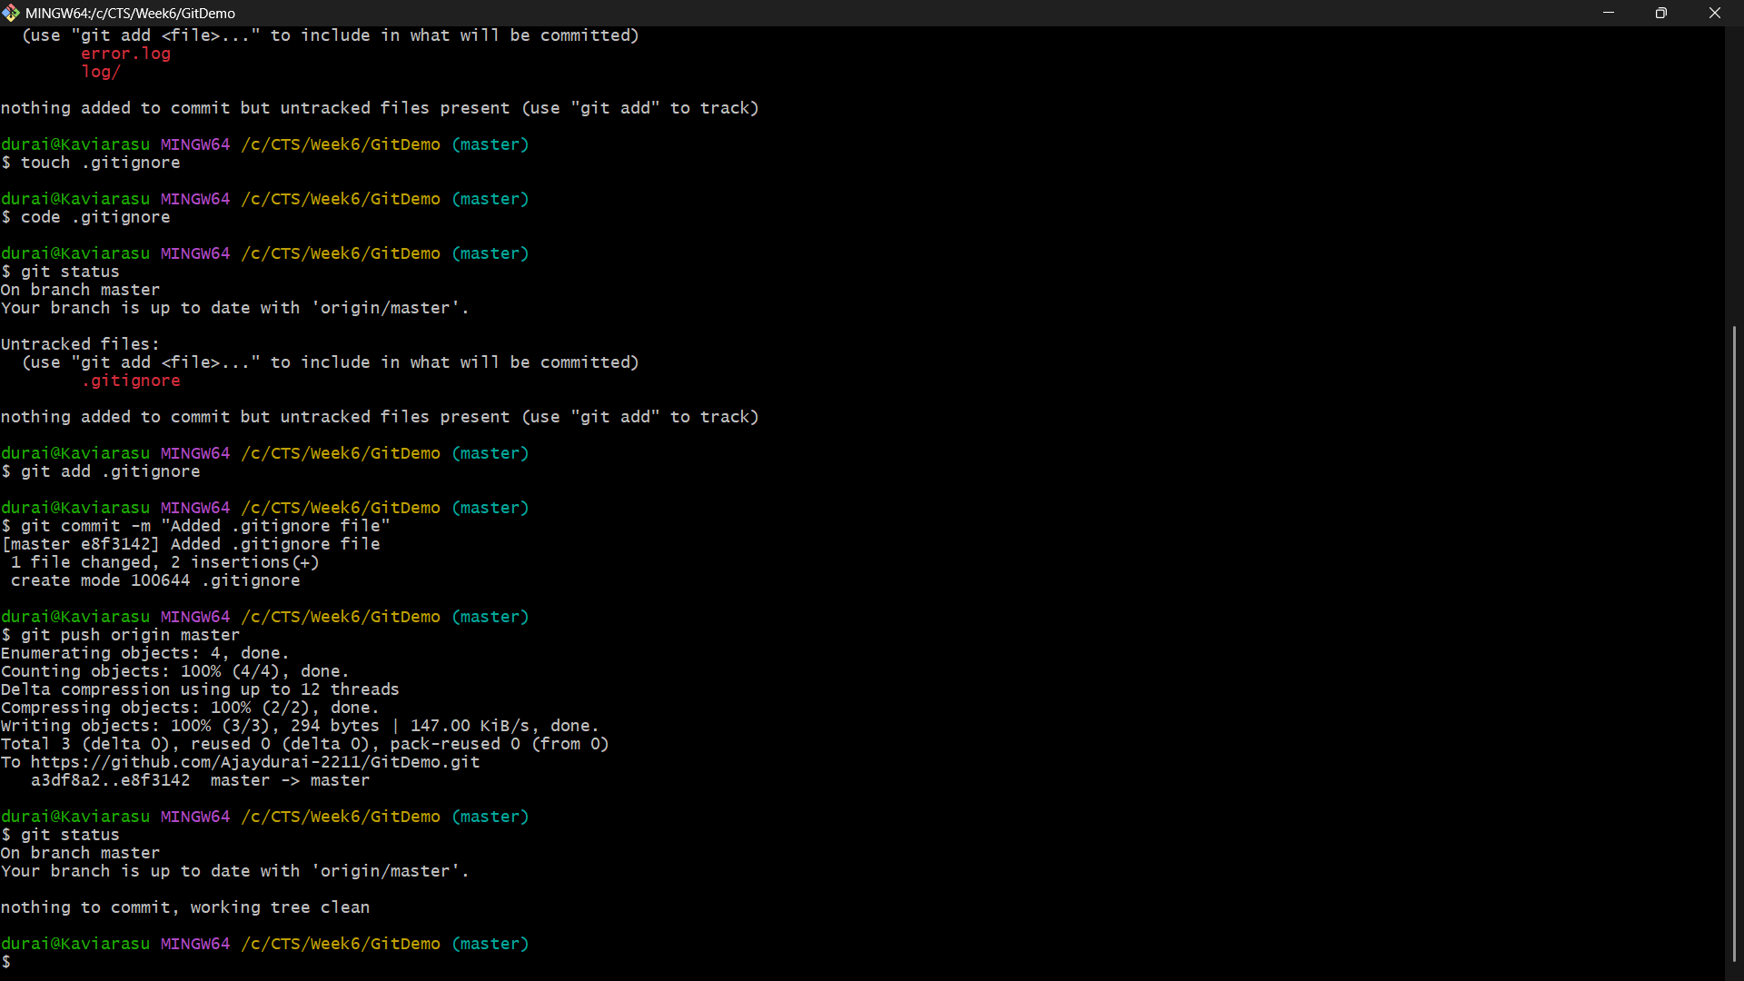
Pushing Changes to GitHub and Verifying the Repository:
